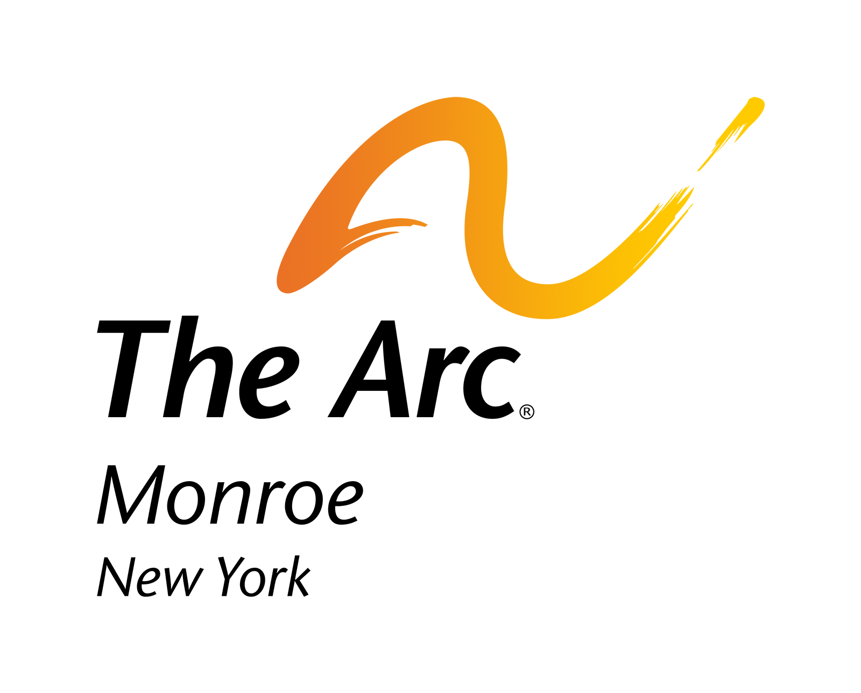

2060 Brighton Henrietta Townline Rd.
Rochester, NY 14623

College Internship Application
Welcome to The Arc of Monroe. Thank you for your interest in an internship with our organization. For our records, we request that you please complete this application. This information will remain strictly confidential.

Name _________________________________________________________________ DOB ____/____/____

Address _____________________________________________________________________________________________

City_______________________________ State___________________Zip_______________________________________

Home Telephone ( ) ________________________________ Work/Cell ( ) __________________________________

E-mail Address ________________________________________________________________________________________

Current Employer / School Name ________________________________

Type of Position Preferred: _____________________________________ Short-Term ______ Long-Term ______

What is your availability? Weekdays _____ Weeknights _____ Weekends _____ Holidays ______

Hours Available _______________________________

Please circle all that apply:
Monday Tuesday Wednesday Thursday Friday Saturday Sunday

How much time are you interested in volunteering with The Arc of Monroe? ______ hours per (Month/ Week)

My motivation for an internshp is (Please check all that apply):

Academic Requirement ______ Please share requirement _____________________________________________________
Professional Enhancement ______
Skill Building ______
Personal Growth ______

Have you volunteered or interned with The Arc of Monroe or another organization serving people with developmental disabilities?
______ Yes ______ No

Please share any experiences you have either personally and/or professionally working with people with intellectual and/or developmental disabilities (previous volunteer experience, employment experience, relevant trainings/hobbies/special skills).
_________________________________________________________________________________________________________________________________________________________________________________________________________________________________________________________________________________________________________________
Is there anything else you would like to share about yourself or your internship goals?
Are there any skills that you would like to learn?
____________________________________________________________________________________________________________________________________________________________________________________________________________

Please describe any special activities or programs that you are interested in volunteering for (seasonal, holiday related, special events, particular location or program)?
__________________________________________________________________________________________________________________________________________________________________________________________________________________________________________________________________________________________________________________

Personal References

Please give the names, addresses, and telephone numbers of two people who are sufficiently familiar with your character and that will be able to speak on your behalf as a potential intern with The Arc of Monroe.

Reference Name: _____________________________________________________________________________________
Address: ____________________________________________________________________________________________
Telephone: __________________________________________________________________________________________
Years of acquaintance: ____________________ Occupation of Reference: ______________________________________
Relationship to applicant: _______________________________________________________________________________

My Statement: (Please read thoroughly)
By completion of this application and signature below, I affirm that the above information is true and accurate. I authorize The Arc of Monroe to contact my personal references for a complete account of their experience with me. I also understand that to ensure the safety and well-being of all people supported by The Arc of Monroe, my background will be checked. In the event of placement, if I have provided false or misleading information during the application process, this may be grounds for immediate dismissal.

Applicant signature ____________________________________________________ Date ____________________________

If applicant is under 18 years of age:
I am aware of my child’s interest in becoming an intern with The Arc of Monroe and I give my full permission.

Parent / Guardian Signature _____________________________________________ Date ____________________________

We thank you for your time. Please return the application via email or hard copy to:

The Arc of Monroe
Michelle Bubel-Kempa, HR Manager/HRBP
2060 Brighton Henrietta Townline Rd.
Rochester, NY 14623
mkempa@arcmonroe.org
(585) 271-0660 ext. 1403

11/24

